**Effects of artificial Shelter on Microclimate in Arid and Semi-Arid regions: A Potential Tool for Conservation.**

Nargol Ghazian1*, Mario Zuliani1, Michael Westphal2, and Christopher J. Lortie1, 3.

1Department of Biological Science, York University, 4700 Keele St, Toronto, ON M3J 1P3, Canada

2US Bureau of Land Management, Central Coast Field Office, 940 2nd Ave, Marina, CA 93933, United States

3National Centre for Ecological Analysis and Synthesis (NCEAS), 735 State St #300, Santa Barbara, CA 93101, United States

*Corresponding Author: Department of Biological Science, York University, 4700 Keele St, Toronto, ON, M3J 1P3, Canada. Email: [nargolg1@my.yorku.ca](mailto:nargolg1@my.yorku.ca)

QUICK IDEA

Instead of effects of artifical shelter - only

REUSE ALL THE CUYAMA data and have shelter-open and then use the shrub-open data - even a tiny bit of it here to contrast? OR use Panoche data. I have some old data bit you have some new data.

Add climate data from local weather station too - you NEED that for sure. OR scrape worldclim etc. Need validation data from another source for the site.

**LIST**

1. Ecological Engineering be a dream journal. Let's try. If you can beef.protein this up a bit more, we have a super chance.2. Need to test mean and coefficient of variation too - ie is the relative variance in microclimate in addition to the mean effect different.3. this figure good... but it is really hard to see a difference.. plus you need to plot out the CV

can you also try a time of day as x, then take a mean across all days, so 0 to 24hr on x and then y is mean temp and have three color-coded dots with geom_smooth - THAT would be amazing to see.

4. FINALLY - to get this out - Add one more level to your dataframe or do separately then join in using dyplr later but you need to answer the question how well do these mimics emulate actual shrubs.  INTRO - see my suggestions for new logical flow - if you agree with that sales pitch - I think it is critical to have shrub (open) data too.

5. Climate - data - MIKE/NARGOL, we discussed before - but either use a. worldclim or b. scrape the nearest weather station and get data for whatever scale and timeframe you can. Ideally, at least a mean temp for each day you sampled from local weather station.

**Abstract**

Anthropogenic factors such as climate change, land use, urbanization, alongside the spread of invasive species are some of the challenges impacting the arid and semi-arid regions of the Western United States. Climate change in particular negatively impacts wildfire regimes and in turn increases re-establishment competition between native and invasive vegetation. The canopy of many native plants including shrubs and trees not only provides a refuge from predators for some animals but also offers a shelter from microclimatic stressors. The canopy of native vegetation can be crucial to the survival of other taxa?, it is vital to find modes of conservation whilst post-disturbance landscape recovery is made. In this study, we tested artificial canopies of two shapes (triangle and rectangle) that were easily assembled and were more-cost-effective than existing prototypes discussed in the literature. The shelters were built using PVC piping for the skeletal structure and shade cloths at 3 light blockage intensities including 15%, 50%, and 90%. Furthermore, we paired temperature and light sensor logger to each open-shelter microsite to test the efficiency of the shelters at cooling and shading during the different time blocks of the day. Shelters offered more stable temperatures and more consistent blockage from sunlight compared to the open. This was particularly true during the afternoon and the evening. Triangle shelters were superior and functioned best at 90% blockage. The ‘hole’ pattern on the shade cloths?? What does this mean? functioned similarly to vegetation branches, resulting in irregularities in incoming sunlight, which may offer beneficial thermal and radiative properties that need to be further explored. The use of these shelters can be incorporated into conservation practices in order to mitigate the impacts of anthropogenic disturbance. - LOVE IT - such a cool idea.

Keywords: climate change, microclimate, animals, temperature, light, shelter, variation

**Introduction**

As the rate of anthropogenic climate change increases, many arid and semi-arid regions in the Western United States face extensive ecological shifts as a consequence1. At the current rate, approximately 8% of all species worldwide are expected to become extinct2. Factors such as land-use changes including agriculture in drylands (citation) can further decrease biodiversity by reducing the available terrestrial habitant for plants and for animals3–5. In deserts, animals will not only experience large scale changes such as drought but also small scale changes such relatively more extreme fluctuations in temperature and light -citations to Pugnaire and others showing this 6,7. End with an implication - This evidence suggests that not only do gross, large-scales changes in climate exert pressure on communities and sensitive species in drylands but fine-scale changes and fluctuations can potentially further exacerbate loss.

The type of vegetation that covers a terrestrial habitat is an important characteristic that can influence: foraging site selection8, reproduction9, predator-prey interaction10, and thermoregulation11. Many of the above can be classified as a positive interaction between the vegetation and beneficiary species. ?? CUT OR develop into proper paragraph - I think you could do a paragraph on shrubs and how other dryland woody vegetation functions to provide shelter and refuges that can facilitate other plants (Filazzola et al review paper) and animals too in numerous ways (Lortie et al Functional Ecology review). Then explain that shrubs can be both expanding in cover in some grassland systems but declining in others. Given their incredible role as foundation speices, it is both a. Reasonable to test their role for simple functions such as thermal shelter for animals and b. Directly test shelter through mimics as means to conserve hetereogeneity in deserts for animals - SNAP. Then cite papers and state the conserving structural diversity in all ecosystems in addition to species diversity is critical. PERFECT.

The state of California is home to many diverse landscapes, many of which are dominated by a relatively high diversity of shrubs12. Species such as *Ephedra californica* (Mormon Tea) are known to be foundational plants, able to provide a variety of benefits to protégé species through various mechanistic pathways that include, but are not limited to, seed trapping, abiotic stress amelioration, and soil modification13. In many arid and semi-arid regions, dominant shrubs are able to positively facilitate other taxa through the shelter effects provided by their canopy14. Canopy microclimates are generally cooler, more humid, and have lower solar radiation compared to open sites14,15. Shrubs fulfil a critical functional role; hence, more species are associated with shrubs than open spaces16. This is evident in many lizards species such as *G. sila* that are found in shrubs in high afternoon temperatures17. Medium - see above proposed structure

Landscapes changing - shrubs cover up and also down

Shrubs facilitate in many ways including shelter

Previous studies showed structural heterogeneity and diversity in that form important for conservation - for animals in particular.

Shrubs can perform that function but it would idea to have the capacity to mimic this to augment and enhance low shrub cover areas, serve as stopgap tools for conservation *YES< and generally important the direct and simple value of more shelter in some dryland systems as a form of thermal refuges alternate modes of conservation whilst landscape recovery is made and new shrubs are grown.

GOOD now that you made the link in last paragraph from climate change to shrubs to shelter to structural heterogeneity have a short paragarph reviwing what we know about shelters… Artificial canopies, such as rainout shelters and Open-Top-Chambers (OTC), have been used to study the change in a variety of abiotic parameters such as CO2, temperature, soil temperature, solar radiation, and humidity 21,22. Although these shelters are effective, they’re relatively expensive to build and may be difficult to assemble in a short period of time. The landscape alongside the climate of southern California provides us with the opportunity to explore the effects man-made shelters that are inexpensive and can easily be assembled in the field. A cheaper alternative that pioneered in this study is UV Permeable Shade Cloth Shelters (UPSS) made with PVC pipe skeleton and shade cloth cover. Need to also mention the rainout shelters tested in deserts and grasalands globally and what they found. ALSO ensure you link to whatever temperature effects these studies report too since you that is what you are testing here.

Topic sentence first = Shelter from higher and more variable temperatures in drylands is thus an important concept to explore experimentally for conservation and restoration. In this study, the following three goals were examined. (1) To describe the methodology of constructing UPSS for drylands. (2) To explore UPSS effects on canopy microclimate including temperature and light intensity. (3) To examine how different light permeabilities shelter shapes influence the above parameters. GOOD. Artificial structures are not uncommon in drylands for energy and development now (citations), and a deeper understanding of physical structure impacts at fine-scales can also inforam some of the ecology of these changes. as well as natural vegetation have the ability to alter their canopy’s microclimate, it was predicted that the highest blockage intensity would result in the greatest cooling effect and would be the most effective at lowering solar radiation. Furthermore, rectangular shelters would be better at cooling compared to those that are triangular as triangle blocks wind more effectively, leading to air stagnation and an increase in temperature (temperature stagnation)23. These predictions were tested by deploying temperature and light loggers inside and outside of shelters. CUT OR… pick one approach

Three goals are revised above OR

Change to hypothesis and predictions?

H: Shelter will change microclimate at fine-scales and provide heterogeneity relative to open sites.

Pred 1. Mean and variation in temp and light will be reduced relative to open.

Pred 2. Which shape better.

Pred 3. Best permeability.

Then end with conclusion - This study will thus demonstrate…., and this is important because animals experience at fine scales.

IF YOU CAN ADD ANY SHRUB DATA? Alex has some from Panoche or reuse my Cuyama shrub-open data, even one year then you have a better story. Compare mean and coefficient of variation in shrub-open and then shelter open.

OK spent a few days digging around

Cuyama best data.

However, if you want to match match Panoche - have a few datasets too - emailed you link With this doc.

DO all above BUT we also need to see SHRUB data - if it makes sense to add we add the prediction Artifical shelters approximate shrub canopy effects. Finally, NOT a prediction, but you need weather station data too or some other climate source even for the site even daily temps to get a sense how close these loggers are to larger climate measures.

**Materials & Methods**

***Study site***

This study was conducted in Panoche Hills Management Area located on the western edge of the San Joaquin Valley, California (Bureau of Land Management; 36◦41.78′ N, 120◦47.89′ W). The regional climate can be characterized as arid/semi-arid. The average annual precipitation is 25.5 cm with an annual low and high temperature of 10.4 ºC and 76.3 ºC, respectively. Winter and fall are considered to be the wettest seasons. The mean temperature observed in May is 20.4 ºC and 23.7 ºC in June (Los Baños Weather Station, <http://www.usclimatedata.com/>). The region is heavily dominated by invasive grasses such as: *Bromus madritensis ssp. Rubens, Bromus hordeaceus, Erodium cicutarium* and *Schismus barbatus (Cite an Alex paper here)*.

***Shelter Construction***

Shelters were constructed using PVC piping and UV permeable shade cloths at three permeabilities including 15%, 50%, and 90%. The open (no structure) at 0% light blockage served as control. - did you also have a PVC frame without shade cloth as a control for frame effects? Just an idea. The cloths were attached to the PVC using zip ties. Table 1 describes the number of pieces at specific dimensions and diameter needed to build each triangle or square shelter. Move to appendix There were six replicates of each shape-two pertaining to each blockage percentage-for a total of 12 replicates. Pipes were slid onto metal stakes, which were hammered into ground for stability (Supplementary Appendix; Figure 1). Latitude and longitude coordinates of each shelter-open pair was also recorded (Table 1; Supplementary Appendix). Rectangular (referred to as square in stats) shelters consisted of two sides with two 61 cm ½ inch pipes facing the ground connected to a 61 cm ¾ inch pipe using a 90º elbow. Triangular shelters were built using a 75 cm ¾ inch top pipe connected to a ½ inch to ¾ inch adapter. The adapter was then attached to a ½ inch 3-way 90º elbow fitted with two 61 cm ½ pipes. Cloths were used to cover two side of the triangular shelters and three sides of the rectangular shelters. The cardinal direction or orientation of each shelter was decided using a random number table and recorded . Shelters were inspected weekly throughout deployment.

Put tables and figure at the end of document. Most journal require this.

I think the journal Ecological Engineering would be PERFECT for this paper. SO go to that journal and grab a bunch of papers, cite them, and also see how they write and style their papers.

MOVE to appendix.

**Table 1.** A list of PVC pieces used for shelter skeleton construction is provided alongside the quantity needed to build one of each shelter-type.

|  |  |  |
| --- | --- | --- |
| **Piece** | **Quantity for Triangular Shelter** | **Quantity for Rectangular Shelter** |
| 61 cm (½ inch diameter) pipe | 4 | 4 |
| 61 cm (¾ inch diameter) pipe | NA | 2 |
| 75 ¾ cm pipe | 1 | NA |
| ½ inch to ¾ inch adapter | 2 | NA |
| ½ inch to ¾ inch 2-way 90º elbow | NA | 4 |
| ½ inch 3-way 90º elbow | 2 | NA |

***Micro-climatic measurements***

To measure the difference in light and temperature within shelters and between shelters and open microsites, Onset HOBO Temperature/Light Pendant (8K) loggers were placed inside and directly outside to the right of the shelters. A total of 24 pendants were used, where each pendant was tied to a plastic stake using a zip tie. Stakes were hammered into the ground until stable with ~10 cm remaining above ground. This was done to ensure that logger data were not influence by ground cover and true ambient conditions both inside and outside were recorded. Air temperature (ºF) and light intensity (lum/ft2) were recorded hourly. Loggers were placed out mid-May (20th) and collected in mid-June (12th), 2019 to represent spring-summer seasonal variation. Data collected were then categorized into time blocks: morning (6 AM-11:59 PM), afternoon (12 PM-11:59 PM), and evening (12:00AM-5:59AM).

**Shrub micro-climatic data**

Explain how measured shrubs..

**Bonus from Mario**

**Cam trap temp data.**

**Macro-climatic data**

Local weather station etc.. SEE papers from Alex etc from how we got local data for Panoche and explain here - even just daily means for every day you sampled be great.

Then you are test whether mean daily temp via t-test/anova or simple test under shrub, shelter, or open is different from the mean estimate by weather stations? If different - wow great - ie I can imagine that under shrub and shelter different but open not? HOW wicked would that be right???!!

however, average annual precipitation is 25.5 cm with mean monthly temperatures of 8.9°C in January and 26.1°C in July (Los Banos Weather Station data at 37°03.30′N, 120°51.00′W from US Climate Data 2016; **<https://www.usclimatedata.com/>**). During the 2013–2014 growing season from October to April, rainfall within this region was classified as an exceptional drought (D4, the highest category) by the United States Drought Monitor (United States Drought Monitor, **2016**). The total amount of precipitation that fell during this period was *c*. 8.5 cm and represents *c*. 33% of the average annual precipitation (US Climate Data 2014; **<https://www.usclimatedata.com/>**)

***Statistical Analyses***

All statistics were performed using R version 3.6.124. Code is published at Zenodo (citation), and data are published at Figshare (citation). The relationship between temperature and light intensity was examined using Kendall’s rank correlation (non-parametric, continuous data) state stats tested used only not how your plotted. GLMs were used to compare temperatures, shape, and cover type with time block serving as a covariate (Citations). Reword dand state more clearly how you tested distribution to decide what model to fit. GLM dispersion parameters and AIC scores were used to compare and select the appropriate fit (citations) - you mean to decide on what family to fit?. Post-hoc tests were does with the function *emmeans from the* *emmeans* library)26.

NEED TO TEST RELATIVE VARIATION TOO - COEFFICIENT OF VARIATION - DO SOME RESEARCH ON THAT, CITE, AND COMPARE CV FOR EACH TIME BLOCK FOR TEMP AND MAYBE LIGHT.

ALSO - I WOULD DO HOURLY CONTRASTS TOO. JUST PICK ON THE ON HOUR FROM 0 TO 24 (TREAT AS CATEGORICAL PERHAPS) AT LEAST FOR TEMP AND MABYE DO JUST THE DAYLIGHT HOURS FOR LIGHT - YOU CAN LOOK UP SUNRISE AND SUNSET DATA ONLINE FOR THE DAYS YOU SAMPLED, MAYBE A TABLE WITH DATA, SUNRISE, SUNSET AS COLUMNS AND PUT IN APPENDIX - THEN USE THOSE HOURS TO DO THE LIGHT BUT DO ALL THE HOURS FOR TEMP.

THEN DO A 0-24HR PLOT AS X-AXIS AND Y FOR MEAN TEMP AND CV TEMP AND THEN LIGHT ETC… NEED TO SEE A FEW WAYS TO LOOK AT DATA.

ALSO DO THE SAME IDEA, SIMPLER USING LOS BANOS DAILY/HOURLY DATA.

**Results**

**Temp significantly increased with light intensity during daylight hours (**Figure 1, 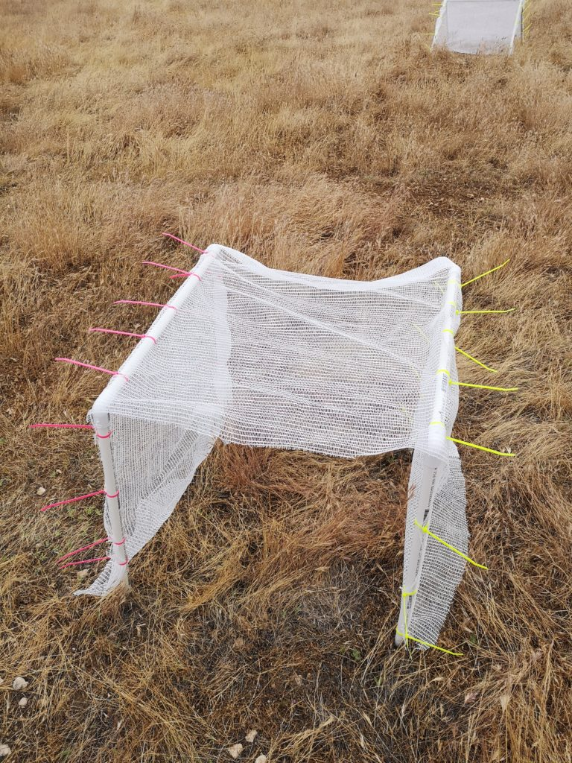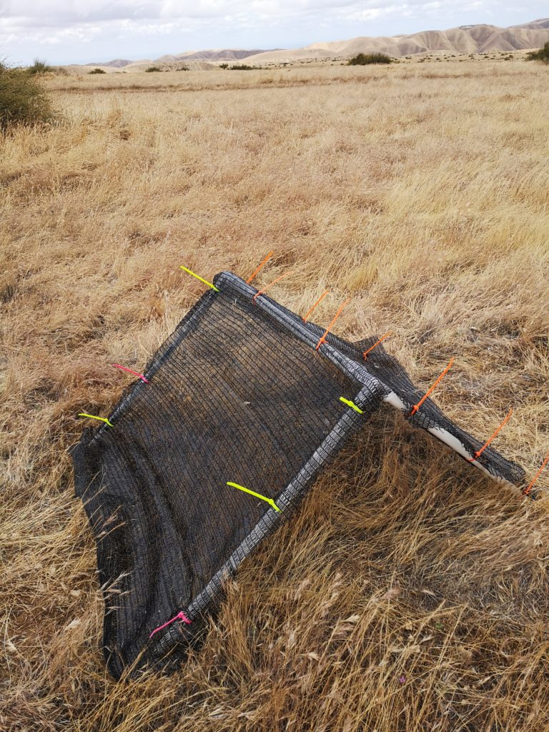Kendall’s tau= 0.487, p = 0.0001). This was true irrespective of shape, time block, or blockage intensity/cover type (NO cite a GLM with shape as a factor in stats model etc. Fig. 3-6 Supplementary Appendix). Shelters significantly altered MOVE these pics to appendix.

ALSO have a pic of what ephedra looks like too./

canopy microclimate during the study period at all times of the day. There were significant differences between the different blockage intensities when predicting temperature (ANOVA F= 5.763, p= 0.016) and light intensity (ANOVA F= 213.68, p<2.2e-16) - PUT these stats into tables. You should be presenting GLM stats not anova stats.. Differences between rectangle and triangle were particularly important during the evening (p<0.0001), Furthermore, the various structures also affected temperature (ANOV F= 90.484, p<2.2e-16) and light (ANOVA F=37.154, p<2.2e-16) in significantly different ways. Light blockage intensity (cover type), shape, and time block were used as predictors for temperature and light intensity GLM. Revise - CHECK some papers Eco Engin.. and see how they report stats - for most other ecology journals you just put all stats in table etc.. state directly.. during all times of the day; however, this comparison was only significant at 90% blockage (Table 2; p<0.0001). Triangle was also superior to rectangle when it came to lowering the light intensity. At 50% and 90% blockage triangle showed to more effective at controlling incoming light (Table 3; p<0.0001). This was true regardless of the time of the day. However, rectangle was better at reducing incoming light at 15% light blockage (p<0.0001). The open microsite also showed to experience lower sunlight intensity than triangle at all time blocks (p<0.0001). Revise - confusing.

Also add relative variation etc.

MOVE TABLES AND FIGURES TO END OF DOCUMENT

**Figure 1. Left-Triangular shelter with 90% shade cloth attached to PVC skeleton using zip ties. Right-Rectangular shelter with 15% shade cloth attached to two PVC skeletal frames. AND MOVE THIS FIG TO APPENDIX**

**Table 2. Emmeans values and standard error for square and triangle shelters are given for the different time blocks of the day at Panoche Hills, CA. Values are for *emmeans* comparison with temperature as the response variable. Values were compared using a pairwise method???. Significance is measure at α < 0.05 and bolded if significant. Only significant comparisons were included in the table. Hmmmm think you need a more detailed table.**

|  |  |  |  |  |  |
| --- | --- | --- | --- | --- | --- |
| **Time Block** | **Blockage Intensity (%)** | **Rectangle** | **Triangle** | **Effect Size (z)** | **p-value** |
| Afternoon | 90 | 89.9±1.115 | 83.5±1.108 | 5.431 | **p<0.0001** |
| Evening | 90 | 84±0.878 | 77.6±0.870 | 5.431 | **p<0.0001** |
| Morning | 90 | 80.08±0.862 | 74.4±0.855 | 5.431 | **p<0.0001** |

**Table 3. Emmeans values and standard error for square and triangle shelters are given for the different time blocks of the day at Panoche Hills, CA. Values are for GLM with light intensity as the response variable. Values were compared using a pairwise method. Significance is measure at α < 0.05 and bolded if significant.**

|  |  |  |  |  |  |  |
| --- | --- | --- | --- | --- | --- | --- |
| **Time Block** | **Blockage Intensity (%)** | **Rectangle** | **Triangle** | **No Structure** | **Effect Size (z)** | **p-Value** |
| Afternoon | 0 | NA | 8.80±0.015 | 8.43±0.00055 | -24.357 | **p<0.0001** |
| Afternoon | 15 | 7.98±0.001 | 8.86±0.00096 | NA | -739.449 | **p<0.0001** |
| Afternoon | 50 | 7.45±0.001 | 7.05±0.001 | NA | 193.211 | **p<0.0001** |
| Afternoon | 90 | 7.97±0.001 | 7.31±0.001 | NA | 430.142 | **p<0.0001** |
| Evening | 0 | NA | 8.30±0.015 | 7.93±0.0003 | -24.357 | **p<0.0001** |
| Evening | 15 | 7.48±0.0009 | 8.36±0.0008 | NA | -739.449 | **p<0.0001** |
| Evening | 50 | 6.99±0.001 | 6.553±0.002 | NA | 193.211 | **p<0.0001** |
| Evening | 90 | 7.47±0.0009 | 6.81±0.001 | NA | 430.142 | **p<0.0001** |
| Morning | 0 | NA | 8.38±0.015 | 8.0±0.0003 | -24.357 | **p<0.0001** |
| Morning | 15 | 7.55±0.0009 | 8.44±0.0008 | NA | -739.449 | **p<0.0001** |
| Morning | 50 | 7.07±0.001 | 6.63±0.002 | NA | 193.211 | **p<0.0001** |
| Morning | 90 | 7.54±0.0009 | 6.89±0.001 | NA | 430.142 | **p<0.0001** |

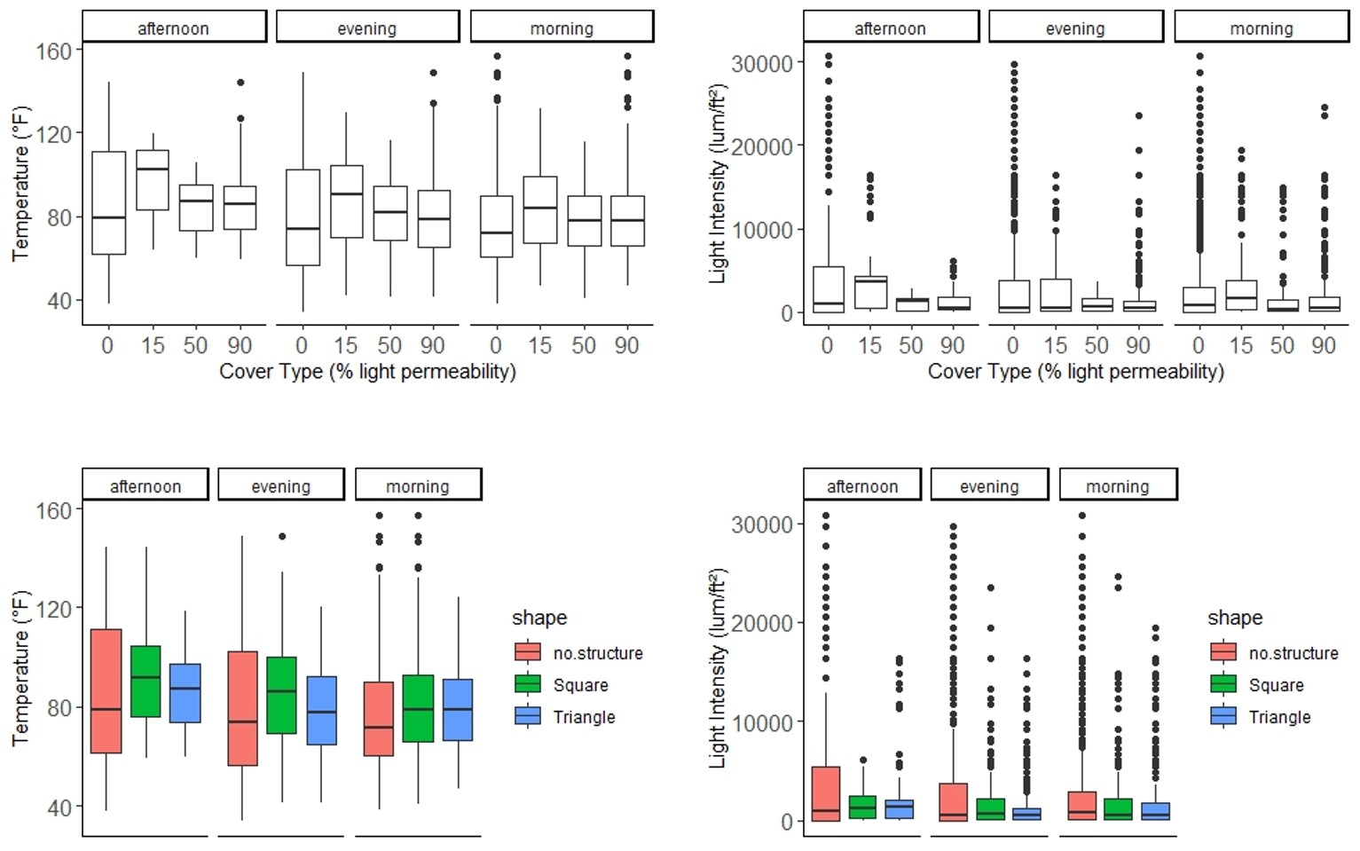

**Figure 2. The relationship between temperature (ºF) and the different blockage intensities and shape for the three time blocks. These relationships are also shown for light intensity (lum/ft2). Solid middle lines shows the median of the data, whilst whiskers show 1.5 standard deviation. Solid dots are outliers >1.5 interquartile range (IQR).**

**OK On all these plots - see suggestions for other ideas too.**

**Rename no structure to ‘open’ or control**

**Try other plots I love boxplots but hard to see differences**

**Discussion**

**Restate purpose - Shrubs and structural heterogeneity are important components of ecosystems relevant to the conservation and restoration of other plants and animals. Shelter that provides amelioration or even just differences in the temperature and light at fine-scales is likely critical to at least some sensitive animals (citaations) and to plants that require different germination conditons (citations). Here, we tested… either the hypothesis or we examined the capacity for.. whatever framework you prefer.. I would say maybe H and preds??/**

**Here, we tested the hypothesis that artificial shelters can both emulate shrub canopy effects in deserts and change key measures of microclimate including temp and light. This hypothesis was supported. Then work through preds —- whatever they are - light different and mean temp, variation is reduced in temp, and shelters were similar to shrub canopies and different from coarser-scale climate estimate from a nearby weather station. This evidence suggests that shelters can provide an important mechanism or tool for stakeholders to provide habitat for plants and animals either as a temporary stepping stone restoration strategies or as a means to enhance habitat quality through simple and cost effective interventions.**

**Then paragraphs discussing each key finding**

**Para 2 Temp and light finding..**

**Para 3 Mean changes in temp in light**

**Para 4 the importance of variation in climate in addition to mean changes and scale of changes AND THE IMPORTANCE OF SHELTER AND HETERO… YOU have some of these ideas below. CHECK ECo-ENG journal and see how deep they go in their papers.**

**Para 5 SHORT conclusions with implications.**

The open microsites showed the most variation in data compared to two other structures for both temperature and light intensity (Figure 2), specifically during the afternoon and evening time slots. Furthermore, the open also showed the most variation compared to the other blockage intensities, except during the morning when the 15% cover type experienced the most variation. This demonstrates that although there may be specific times during the day when no shelter may be better than any shelter, the open simply does not offer the same consistency of refuge from extreme environmental conditions as shelter does. The spatial and temporal patterns of thermal heterogeneity are able to create unique selective pressures in different environments28. Shaded microhabitats, such as those created by vegetation, are vital components that increase thermal heterogeneity of the landscape for a variety of animals such as ectotherm, in addition to providing refuge29,30. Our data supports the hypothesis that shelters too can act as canopies that increase thermal heterogeneity within a given environment. SURE YOU HAVE A WHOLE PARAGARPH ON CONSERVATION RESTORATION ABOUT THIS. GREAT.

Signs of human-induced climate change is already visible in a variety of ecosystems. Species all around the world face changes in distribution and abundance due to migration and range shift32. This change with impact the physiology, growth, and productivity of biota33, as well as their behaviour34. Given the current rates, it will not be long before species can no longer physiologically and behaviourally mitigate the impacts of climate change. Animals such as lizards may already be over-expending energy when trying to thermoregulate35. Thus, the importance of shelter as a climate refuge is now more crucial than ever. See above. Work into the paragraph above

In California, climate change is further interfering with wildfire regimes and altering biological communities36. Not only can post-disturbance recovery be slow20 competition and invasion by non-natives is amongst other problems slowing the recruitment of native vegetation37,38. A clear implication is therefore the benefits of shelters as a mode of conservation post-disturbance whilst other efforts are made to re-establish the native community. REORGANIZE ALL THIS

END WITH IMPLICATIONS AND SIMPLY RESTATE MAIN FINDINGS.

**Funding**

This research was made possible through a Natural Sciences and Engineering Research Council of Canada (NSERC) grant awarded to CJL and the Mitacs Globalink award, alongside York University Faculty of Graduate Studies (FGS) award granted to NG and MZ.

**Acknowledgements**

We are thankful to BLM for allowing us to conduct research in their land. We are grateful to M. MacDonald for her help in designing the project and editing the manuscript. We also thank J. Braun, M. Owen, and S. Haas for their feedback on statistical analyses.

**Literature Cited**

1. Abatzoglou, J. T. & Kolden, C. A. Climate Change in Western US Deserts: Potential for Increased Wildfire and Invasive Annual Grasses. *Rangel. Ecol. Manag.* **64**, 471–478 (2011).

2. Urban, M. C. Accelerating extinction risk from climate change. *Science* **348**, 571–573 (2015).

3. Nopper, J., Riemann, J. C., Brinkmann, K., Rödel, M.-O. & Ganzhorn, J. U. Differences in land cover – biodiversity relationships complicate the assignment of conservation values in human-used landscapes. *Ecol. Indic.* **90**, 112–119 (2018).

4. Irwin, M. T. *et al.* Patterns of species change in anthropogenically disturbed forests of Madagascar. *Biol. Conserv.* **143**, 2351–2362 (2010).

5. *Urbanization, biodiversity and ecosystem services: challenges and opportunities: a global assessment ; a part of the cities and biodiversity outlook project*. (Springer, 2013).

6. Titus, J. H., Nowak, R. S. & Smith, S. D. Soil resource heterogeneity in the Mojave Desert. *J. Arid Environ.* **52**, 269–292 (2002).

7. Pianka, E. R. Convexity, Desert Lizards, and Spatial Heterogeneity. *Ecology* **47**, 1055–1059 (1966).

8. Thiele, T., Jeltsch, F. & Blaum, N. Importance of woody vegetation for foraging site selection in the Southern Pied Babbler (Turdoides bicolor) under two different land use regimes. *J. Arid Environ.* **72**, 471–482 (2008).

9. Thyen, S. & Exo, K.-M. Interactive effects of time and vegetation on reproduction of redshanks (Tringa totanus) breeding in Wadden Sea salt marshes. *J. Ornithol.* **146**, 215–225 (2005).

10. *Ecology of predator-prey interactions*. (Oxford University Press, 2005).

11. Parmenter, R. R. & MacMahon, J. A. Factors determining the abundance and distribution of rodents in a shrub-steppe ecosystem: the role of shrubs. *Oecologia* **59**, 145–156 (1983).

12. Stuart, J. D. & Sawyer, J. O. *Trees and shrubs of California*. (University of California Press, 2001).

13. Filazzola, A. & Lortie, C. J. A systematic review and conceptual framework for the mechanistic pathways of nurse plants: A systematic review of nurse-plant mechanisms. *Glob. Ecol. Biogeogr.* **23**, 1335–1345 (2014).

14. Filazzola, A. *et al.* Non-trophic interactions in deserts: Facilitation, interference, and an endangered lizard species. *Basic Appl. Ecol.* **20**, 51–61 (2017).

15. Holzapfel, C. & Mahall, B. E. Bidirectional facilitation and interference between shrubs and annuals in the Mojave Desert. *Ecology* **80**, 1747–1761 (1999).

16. Lortie, C. J., Filazzola, A. & Sotomayor, D. A. Functional assessment of animal interactions with shrub-facilitation complexes: a formal synthesis and conceptual framework. *Funct. Ecol.* **30**, 41–51 (2016).

17. Westphal, M. F., Noble, T., Butterfield, H. S. & Lortie, C. J. A test of desert shrub facilitation via radiotelemetric monitoring of a diurnal lizard. *Ecol. Evol.* **8**, 12153–12162 (2018).

18. Eliason, S. A. & Allen, E. B. Exotic Grass Competition in Suppressing Native Shrubland Re-establishment. *Restor. Ecol.* **5**, 245–255 (1997).

19. Germano, D. J. *et al.* The San Joaquin Desert of California: Ecologically Misunderstood and Overlooked. *Nat. Areas J.* **31**, 138–147 (2011).

20. Berry, K. H., Weigand, J. F., Gowan, T. A. & Mack, J. S. Bidirectional recovery patterns of Mojave Desert vegetation in an aqueduct pipeline corridor after 36 years: I. Perennial shrubs and grasses. *J. Arid Environ.* **124**, 413–425 (2016).

21. Yahdjian, L. & Sala, O. E. A rainout shelter design for intercepting different amounts of rainfall. *Oecologia* **133**, 95–101 (2002).

22. Hollister, R. D. & Webber, P. J. Biotic validation of small open-top chambers in a tundra ecosystem. *Glob. Change Biol.* **6**, 835–842 (2000).

23. Harrison, S. & Cruickshank, C. A. A review of strategies for the control of high temperature stagnation in solar collectors and systems. *Energy Procedia* **30**, 793–804 (2012).

24. R Core Team. *R*. (2019).

25. Wickham, H. *Ggplot2: elegant graphics for data analysis*. (Springer, 2009).

26. Lenth, R. & Herve, M. *Emmeans, Estimated Marginal Means, aka Least-Squared Means.* (2019).

27. Haigh, J. D. The Sun and the Earth’s Climate. *Living Rev. Sol. Phys.* **4**, (2007).

28. Angilletta Jr., M. J. *Thermal Adaptation*. (Oxford University Press, 2009).

29. Diaz, J. A. & Cabezas-Diaz, S. Seasonal variation in the contribution of different behavioural mechanisms to lizard thermoregulation. *Funct. Ecol.* **18**, 867–875 (2004).

30. Bauwens, D., Hertz, P. E. & Castilla, A. M. Thermoregulation in a Lacertid Lizard: The Relative Contributions of Distinct Behavioral Mechanisms. *Ecology* **77**, 1818–1830 (1996).

31. Ivey, K. N., Cornwall, M., Crowell, H., Ghazian, N., Owen, M., Nix, E., Zuliani, M., Lortie, C.J., Westphal, M., & Taylor, M*.* Thermal Ecology of the Federally Endangered Blunt-nosed Leaopard Lizard (Gambelia sila). *Manuscript Submitted for Publication* (2019).

32. Midgley, G. F., Hannah, L., Millar, D., Rutherford, M. C. & Powrie, L. W. Assessing the vulnerability of species richness to anthropogenic climate change in a biodiversity hotspot. *Glob. Ecol. Biogeogr.* **11**, 445–451 (2002).

33. Cannell, M. UK conifer forests may be growing faster in response to increased N deposition, atmospheric CO2 and temperature. *Forestry* **71**, 277–296 (1998).

34. *‘Fingerprints’ of climate change: adapted behaviour and shifting species ranges*. (Kluwer Academic/Plenum Publishers, 2001).

35. Vickers, M., Manicom, C. & Schwarzkopf, L. Extending the Cost-Benefit Model of Thermoregulation: High-Temperature Environments. *Am. Nat.* **177**, 452–461 (2011).

36. Bishop, T. B. B., Gill, R. A., McMillan, B. R. & St. Clair, S. B. Fire, rodent herbivory, and plant competition: implications for invasion and altered fire regimes in the Mojave Desert. *Oecologia* (2019).

37. Bowman, D. M. J. S. *et al.* Fire in the Earth System. *Science* **324**, 481–484 (2009).

38. Bowman, D. M. J. S. *et al.* The human dimension of fire regimes on Earth: The human dimension of fire regimes on Earth. *J. Biogeogr.* **38**, 2223–2236 (2011).

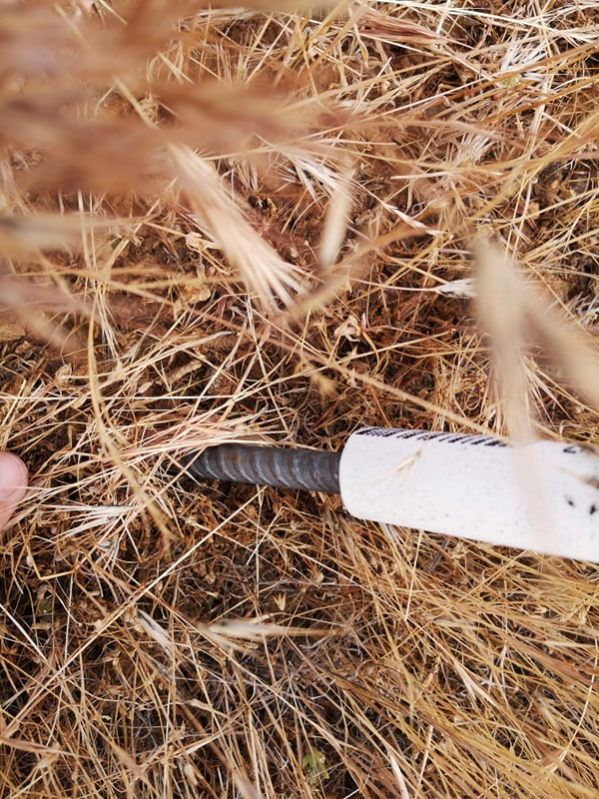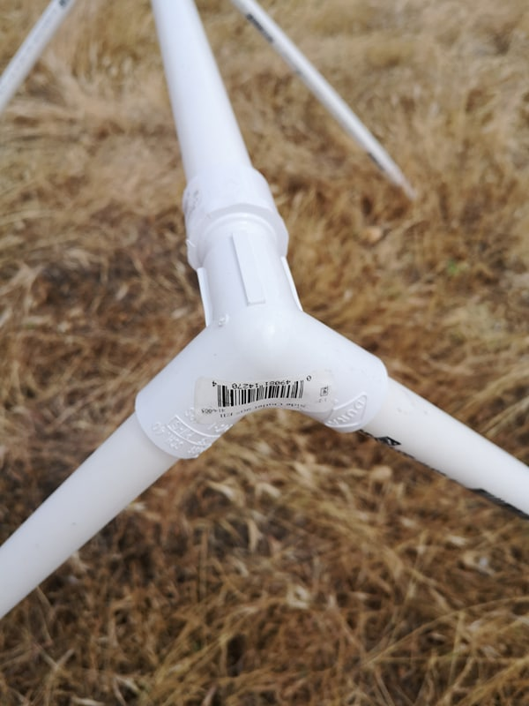**Supplementary Appendix**

**Figure 1. Left- General PVC triangular structure and joint. Right-Metal stake and with PVC pipe slid on.**

**Figure 1. Scatterplot showing the relationship between light intensity (lum/ft2) and temperature (ºF). Blue line represents smooth conditional mean (Kendall’s tau=0.488, z=76.173, p<2.2e-16).**

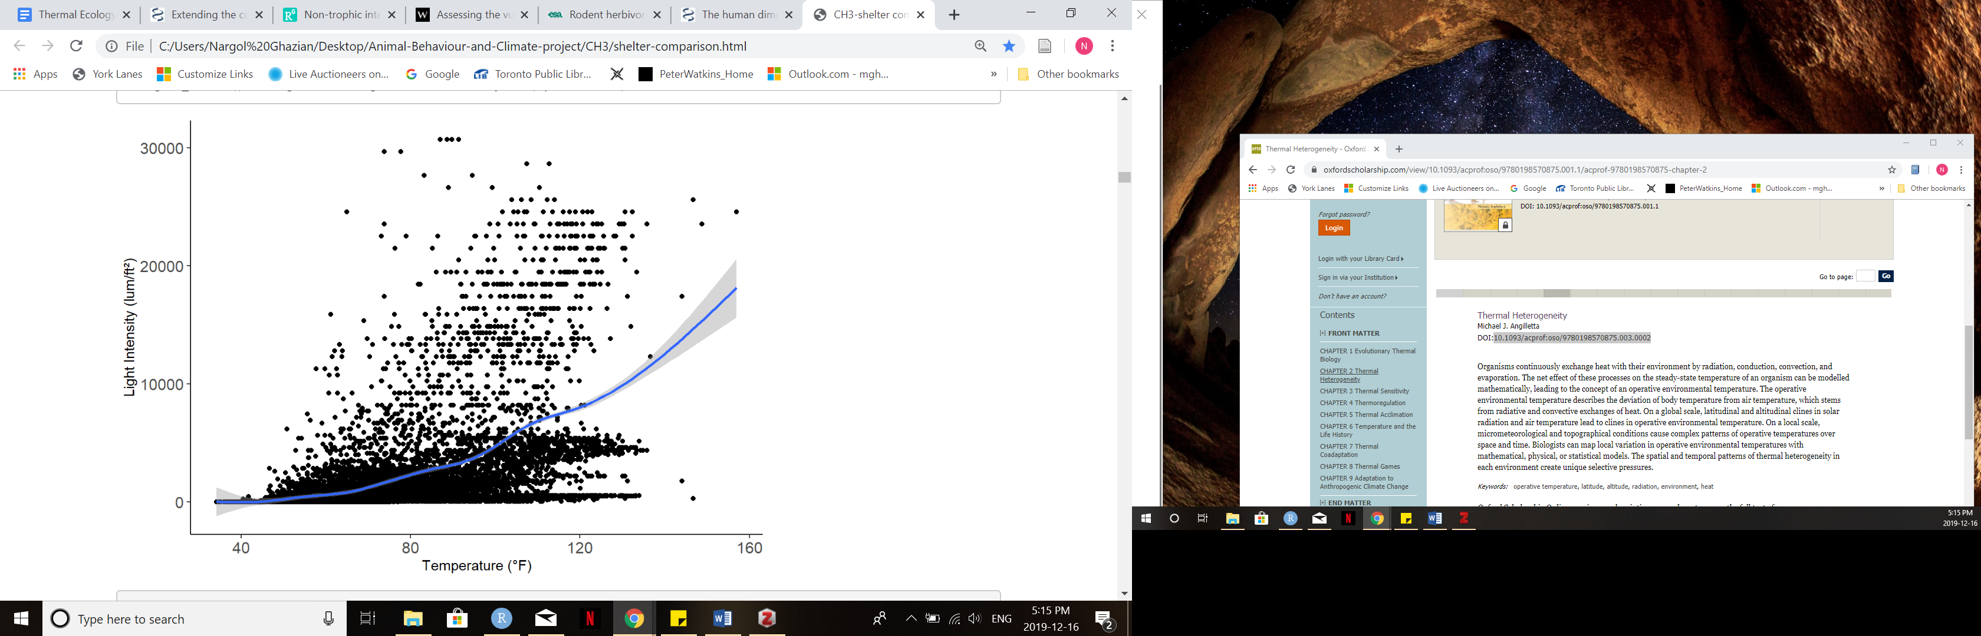

**Table 1. Location (latitude and longitude coordinates) of each shelter-open microsite is given, alongside its shape and cover type. APPENDIX**

|  |  |  |  |  |
| --- | --- | --- | --- | --- |
| ***Shelter ID*** | ***Latitude*** | ***Longitude*** | ***Shape (Triangle/Square)*** | ***Cover type*** |
| *1* | 36.69363 | -120.79318 | T | 15% |
| *2* | 36.69364 | -120.79331 | S | 15% |
| *3* | 36.69355 | -120.79315 | S | 90% |
| *4* | 36.69349 | -120.79320 | T | 90% |
| *5* | 36.69349 | -120.79311 | T | 50% |
| *6* | 36.39342 | -120.79311 | S | 50% |
| *7* | 36.69394 | -120.79300 | S | 15% |
| *8* | 36.69397 | -120.79292 | T | 15% |
| *9* | 36.69401 | -120.79282 | S | 90% |
| *10* | 36.694 | -120.79295 | T | 90% |
| *11* | 36.69405 | -120.79305 | S | 50% |
| *12* | 36.69408 | -120.79301 | T | 50% |